How Big Are Those Shoes?

Assessment Type  Real-life Application of Mathematics | Recommended Grade Level  Grade 9 (MYP4) Extended | MYP Criterion Level  MYP 5

MYP Assessment Criteria  Criterion D: Applying mathematics in real-life contexts | MYP Command Terms Used  identify, apply, find, describe, select, apply, discuss, suggest, explain, justify, use,

MYP Global Context
Orientation in space and time
MYP Key Concepts  Form | MYP Related Concepts  Space, Models, Representation

MYP Branch of Mathematics
Numerical and abstract reasoning
MYP Topics and Skills  - Number operations  - Operating with algebraic expressions  - Substitution into expressions  - Expanding brackets | Prior Knowledge Needed  - Writing mathematical expressions in one variable  - Multiplying binomial by binomial  - Combining like terms to simplify polynomial expressions  - Substitute values into polynomials

Assessment Description

In this assessment, students are presented with a scenario that involves using a variable to represent the length of different wall sections in a room that needs to be painted. As students work through the scenario following logical steps in their calculations, they describe their steps, suggest corrections to given estimates, identify polynomial expressions, calculate lengths and areas, and explain/justify the degree of accuracy used and whether the findings make sense. By the end of the task, students find and justify the possible value of the initial variable.

Materials Needed
The use of a scientific calculator is required. The use of a graphic display calculator is not necessary but allowed.

Task-specific instructions / Recommendations
Students are advised to read questions carefully and consider the hints/tips provided in the various speech bubbles.

Assessment Criterion D: Applying mathematics in real-life contexts

 | Achievement Level Descriptor  (MYP5) | Task Specific Descriptor
0 | The student does not reach a standard described by any of the descriptors below.
1-2 | The student is able to:  - identify some of the elements of the authentic real-life situation  - apply mathematical strategies to find a solution to the authentic real-life situation, with limited success  - (not demonstrated at this level)  - (not demonstrated at this level)  - (not demonstrated at this level). | The student is able to:  - identify the mathematical expressions that represent the measured walls _{(Q1)}  - apply the appropriate mathematical operations to find the required expressions and briefly describe the steps taken _{(Q2)}  - (not demonstrated at this level)  - (not demonstrated at this level)  - (not demonstrated at this level).
3-4 | The student is able to:  - identify the relevant elements of the authentic real-life situation  - select, with some success, adequate mathematical strategies to model the authentic real-life situation  - apply mathematical strategies to reach a solution to the authentic real-life situation  - (not demonstrated at this level)  - discuss whether the solution makes sense in the context of the authentic real-life situation. | The student is able to:  - identify the missing mathematical expression and briefly describe what each of the three expressions in the floor’s area represent _{(Q3)}  - select the appropriate method and briefly describe the steps taken _{(Q4)}  - apply the appropriate method(s) to find the required expression in the simplest form _{(Q4)}  - (not demonstrated at this level)  - discuss the error in Scott’s estimation and suggest a correction _{(Q5)}
5-6 | The student is able to:  - identify the relevant elements of the authentic real-life situation  - select adequate mathematical strategies to model the authentic real-life situation  - apply the selected mathematical strategies to reach a valid solution to the authentic real-life situation  - explain the degree of accuracy of the solution  - explain whether the solution makes sense in the context of the authentic real-life situation. | The student is able to:  - identify the wall whose paintable area is represented by the given expressions _{(Q6)}  - select the appropriate method(s) to find the required values _{(Q7)}  - apply the appropriate method(s) to find the required values _{(Q7)}  - find a reasonable range and explain the degree of accuracy in Scott’s estimation _{(Q8)}  - explain whether Scott’s estimate makes sense for the total paintable area _{(Q8)}
7-8 | The student is able to:  - identify the relevant elements of the authentic real-life situation  - select appropriate mathematical strategies to model the authentic real-life situation  - apply the selected mathematical strategies to reach a correct solution to the authentic real-life situation  - justify the degree of accuracy of the solution  - justify whether the solution makes sense in the context of the authentic real-life situation. | The student is able to:  - identify the number of medium and small cans of paint Scott must have used _{(Q9)}  - select the appropriate method(s) to find the required values and describe each step taken _{(Q10)}  - apply the appropriate method(s) to find the length of Scott’s shoes (Q10)  - suggest the US shoe size that Scott wore and briefly explain and justify why they think so _{(Q11)}  - use the suggested shoe size to find the required values and justify whether those values make sense _{(Q12)}


Scattered Scott was a painter, and he was notorious for forgetting to carry his tools. His name, Scattered Scott, was a nickname he earned over time after other painters learned that he constantly forgot his tools.

In this assessment task, we explore his method to make reasonable measurements for his job: painting walls. How does he do it? What other tools does he use? How accurate are his methods?

Let’s explore!

In his last paint job, once again, staying true to his nickname, Scott did not have his measuring tools. Luckily, he remembered some of the measurements he was told:

- The door was exactly 3 feet wide and 7 feet tall.
- The windows were square-shaped, each measuring 3 feet by 3 feet.
- One of the sides of the small wall on the East side was 3 feet wide.
- The ceiling-to-floor height was exactly 8 feet.

He quickly sketched a floor plan, marked these measurements, and labeled all other sections of the walls from Wall 1 to Wall 7. He then wrote “NOT TO SCALE!!!” in the corner of his sketch.

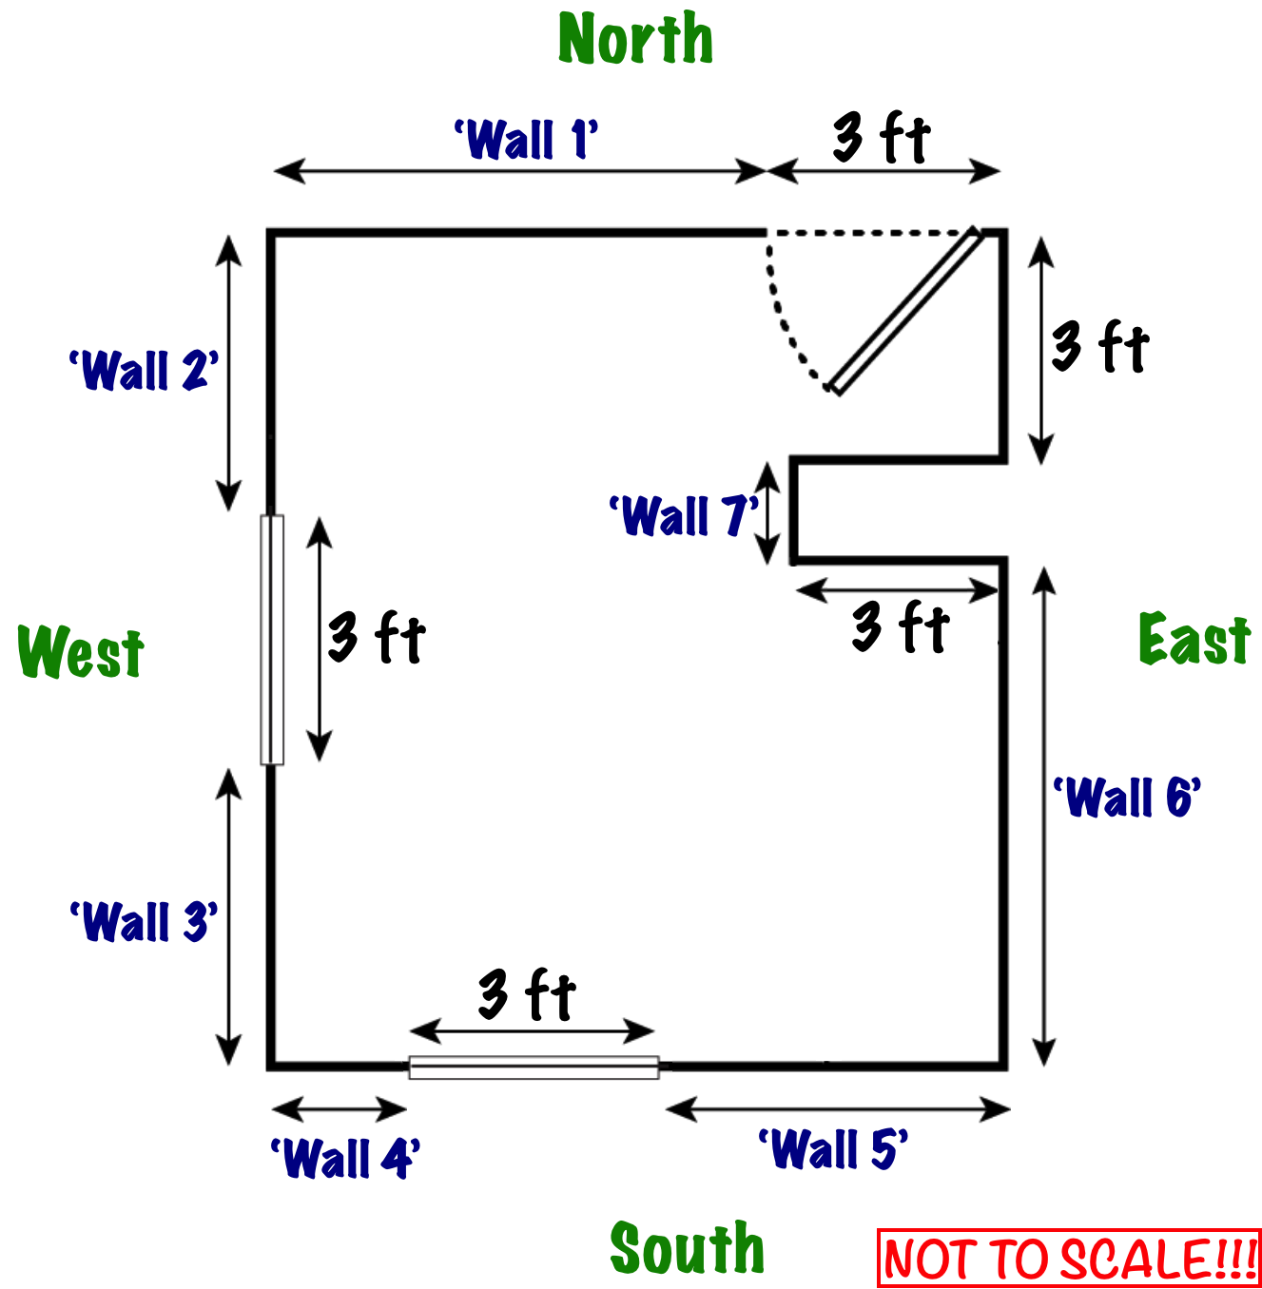

Not having proper measuring tools, Scott decided to use his shoes to measure the length of some wall sections. His measurements were the following:
- Wall 1: about 1/3 of a shoe length longer than 22 shoe lengths,
- Wall 2 and Wall 3: each 13 shoe lengths (a tiny bit shorter, but nearly exactly),
- Wall 4: about 3/4 of a shoe length more than 3 shoe lengths (maybe a bit less),
- Wall 7: a few centimeters shorter than 2 shoe lengths.

Let’s see how we can work with these measurements!

Let $S$ represent the length of Scott’s shoe, in feet, used in the measurements.
- Ignoring the minor inaccuracies, identify mathematical expressions in terms of $S$ to represent the measured walls.

Wall 1 |  | Wall 2 |  | Wall 3 |  | Wall 4 |  | Wall 7
$$22\frac{1}{3}S$$ |  | $$13S$$ |  | $$13S$$ |  | $$3\frac{3}{4}S$$ |  | $$2S$$
[D: 1-2, i]

Scott did not measure all wall sections as he knew he could use what he measured to figure out the rest of the lengths.
- Apply the appropriate mathematical operations to find mathematical expressions in terms of $S$ to represent the length of
  - Wall 5 and Wall 6,
  - the Northern wall, and
  - the Western wall.
For each wall, briefly describe the step(s) taken to find the length.

a) Notice that we have “Wall 1 + 3 feet” = “Wall 4” + 3 feet + “Wall 5”, from which we find that
“Wall 5 = “Wall 1 + 3 feet – 3 feet – Wall 4”, which means the expression for Wall 5 is

$$Wall 5=22\frac{1}{3}S-3\frac{3}{4}S=19S+\frac{1}{3}S-\frac{3}{4}S=19S+\frac{4}{12}S-\frac{9}{12}S=19S-\frac{5}{12}S=18\frac{7}{12}S$$

Notice that we have “Wall 2 + 3 feet + Wall 3 = 3 feet + Wall 7 + Wall 6”, from which we find that
“Wall 6 = Wall 2 + 3 feet + Wall 3 – 3 feet – Wall 7”, which means the expression for Wall 6 is

$$Wall 6=13S+3+13S-3-2S=24S$$

b) The northern wall measures “Wall 1 + 3 feet”, which is $22\frac{1}{3}S+3$.

c) The western wall measures “Wall 2 + 3 feet + Wall 3”, which is $13S+3+13S=26S+3$.

[D: 1-2, ii]

Scott wrote down an incomplete expression to represent the room's floor area:
- Identify the missing mathematical expression below.

Floor’s Area: | $$\left(22\frac{1}{3}S+3\right)\left(26S+3\right)-$$ | $$6S$$

Briefly describe what each of the three expressions in the floor’s area represents.

- The expression $22\frac{1}{3}S+3$ represents the length of the northern (or southern) wall.
- The expression $26S+3$ represents the length of the western (or eastern) wall.
- The expression $6S$ represents the area of the “indented wall” that’s not part of the rectangular floor.

[D: 3-4, i]

- Select and apply the appropriate method(s) to find the expression for the floor’s area in the simplest form. Briefly describe the steps taken.

Using FOIL (First, Outer, Inner, Last), and then combining like terms results in the following:

$$\left(22\frac{1}{3}S+3\right)\left(26S+3\right)=580\frac{2}{3}S^{2}+67S+78S+9=580\frac{2}{3}S^{2}+145S+9$$

Therefore, the floor’s area is
$$580\frac{2}{3}S^{2}+139S+9$$

[D: 3-4, ii-iii]

Scott decided to make a rough estimation, so he said to himself:

“If my shoes are about 10 inches, then the floor area is about $580×100+139×10+10$ or $\left(580+139+1\right)\left(10\right)=\left(720\right)\left(10\right)=7200$ square feet. This is about 670 square meters.”

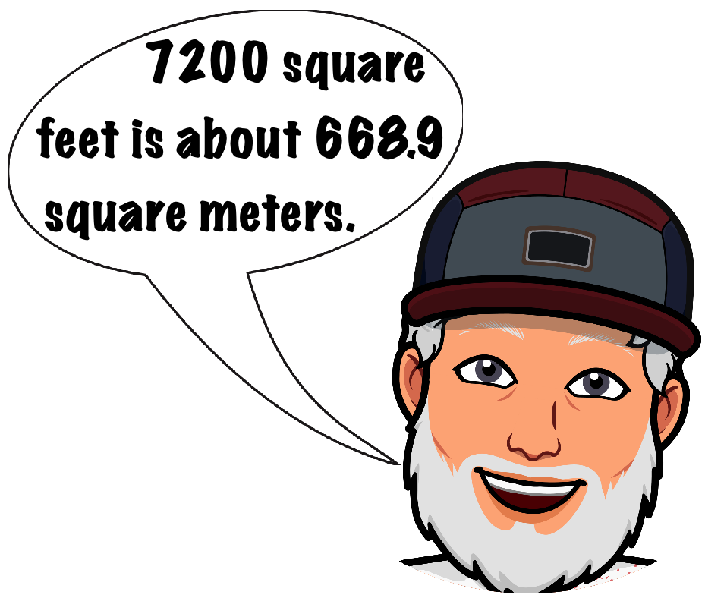
- Briefly discuss the error in Scott’s estimation and suggest a correction that would provide a more reasonable estimation.
(Note: 1 in. = 2.54 cm and 1 ft. = 12 in.)

While it is correct that 7200 square feet is about 670 square meters, this is unreasonably large for a single room. This would mean that the size of the room is approx. 25 meters wide and 25 meters long.

The error in the estimation is that the units in the expressions in all previous questions are feet, not inches, which is what Scott used.

As 1 foot equals 12 inches, 1 square foot equals $12×12=144$ square feet. This means that the 7200 square inches (which is what Scott should have found) is in fact $7200÷144=50$ square feet. This is way more reasonable than 670 square feet.

[D: 3-4, v]

As all four walls needed to be painted, Scott found a mathematical expression, in terms of his shoe size $S$, for each wall. Expressions for two of the four walls are given below.
- Identify the wall whose paintable area is represented by the given expressions.

$$\left(26S+3\right)\left(8\right)-\left(3\right)\left(3\right)$$ |  | $$\left(22\frac{1}{3}S+3\right)\left(8\right)-\left(3\right)\left(7\right)$$
Wall: Western wall |  | Wall: Northern wall

[D: 5-6, i]


- Select and apply the appropriate method(s) to find
  - the simplest form of each expression given in question (6),
  - a mathematical expression in terms of $S$ for
    - the paintable area of the other two walls,
    - the total paintable wall area.

Remember: $S$ represent Scott’s shoe size in feet!

a) Western wall:
$$\left(26S+3\right)\left(8\right)-\left(3\right)\left(3\right)=208S+15$$

Northern wall:
$$\left(22\frac{1}{3}S+3\right)\left(8\right)-\left(3\right)\left(7\right)=178\frac{2}{3}S+3$$

b) Southern wall:
$$\left(3\frac{3}{4}S\right)\left(8\right)+\left(3\right)\left(5\right)+\left(18\frac{17}{12}S\right)\left(8\right)=178\frac{2}{3}S+15$$

Eastern wall (including the indented wall):

$$\left(3\right)\left(3\right)\left(8\right)+\left(2S\right)\left(8\right)+\left(24S\right)\left(8\right)=208S+72$$

c)
Total paintable area:
$$\left(208S+15\right)+\left(178\frac{2}{3}S+3\right)+\left(178\frac{2}{3}S+15\right)+\left(208S+72\right)=773\frac{1}{3}S+105$$

[D: 5-6, ii-iii]

Scott decided to make another rough estimation:
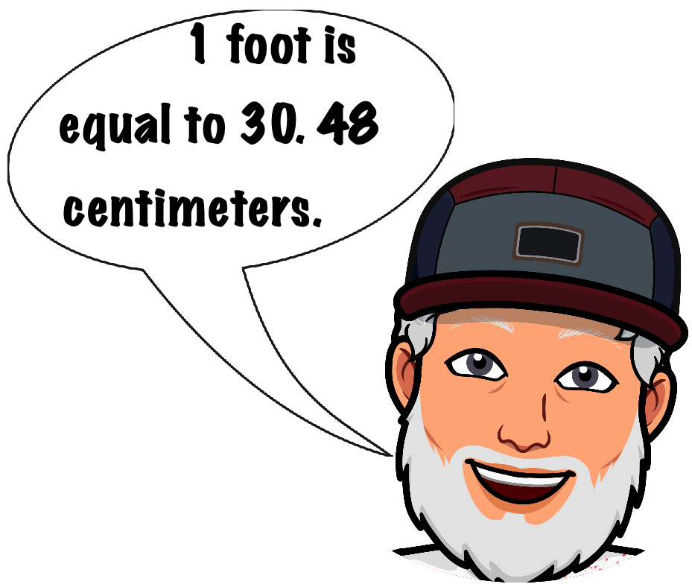
“I’ve painted rooms like this before, and I think the total paintable area is about 75 square meters!”

- Given that Scott’s shoe size is between 25 and 30 centimeters, find a reasonable range for the total paintable area.

Then, explain the degree of accuracy in Scott’s estimation and whether his estimate makes sense for the total paintable area.

Using $S=25$ cm, the total paintable area is
$$\left(773\frac{1}{3}×25+105×30.48\right)×30.48=686,828.192 {cm}^{2}≈68.68 m^{2}$$

Using $S=30$ cm, the total paintable area is
$$\left(773\frac{1}{3}×30+105×30.48\right)×30.48=804,684.192 {cm}^{2}≈80.47 m^{2}$$

This means that Scott’s rough estimate for the total paintable area is quite reasonable, between the calculated 68.68 and 80.47 square meters.

[D: 5-6, iv-v]

When Scott checked his truck, he found several brand-new cans of paint:
- large cans, each advertised to cover an area of 12 square meters,
- median cans, each advertised to cover an area of 7 square meters, and
- small cans, each advertised to cover an area of 4 square meters.
After painting one coat of paint covering the total paintable area, Scott thought to himself:

“If those stickers on the cans are true,
I painted exactly 74 square meters.”

- Given that Scott used 4 large cans of paint and a combination of medium and small cans, identify the number of medium and small cans of paint he must have used (without having any leftover paint).

The 4 large cans of paint he used were good for $4×12=48$ square meters. Thus, for the remaining $74-48=26$ square meters, he must have used a combination of medium and small cans.

If he used 1 medium can, he must have used $\left(26-7\right)÷4=19÷4=4.75$ small cans. However, this would require 5 small cans and would result in leftover paint in the 5th small can.

If he used 2 medium cans, he must have used $\left(26-14\right)÷4=12÷4=3$ small cans. This means he used all paint and there was no leftover paint.

If he used 3 medium cans, he must have used $\left(26-21\right)÷4=5÷4=1.25$ small cans. However, this would require 2 small cans and would result in leftover paint in the 2nd small can.

Therefore, Scott must have used 4 large, 2 medium, and 3 small cans of paint.

[D: 7-8, i]

Given that Scott in fact painted exactly 74 m², it’s time to find out how big Scott shoes are!

- Select and apply the appropriate method(s) to find the length of Scott’s shoes in feet, in inches, and in centimeters. Describe each step of your strategy in detail.

The total paintable area is 74 square meters. In square feet, this is $740,000÷{30.48}^{2}=796.5293708$ square feet. Thus, we have the following equation to solve:

$$773\frac{1}{3}S+105=796.5293708⟹773\frac{1}{3}S=691.5293708⟹S=0.894219…ft$$

In inches, this is equivalent to $0.894219×12=10.730628 in$.
In centimeters, this is equivalent to $0.894219×30.48=27.25579 cm$.

[D: 7-8, ii-iii]

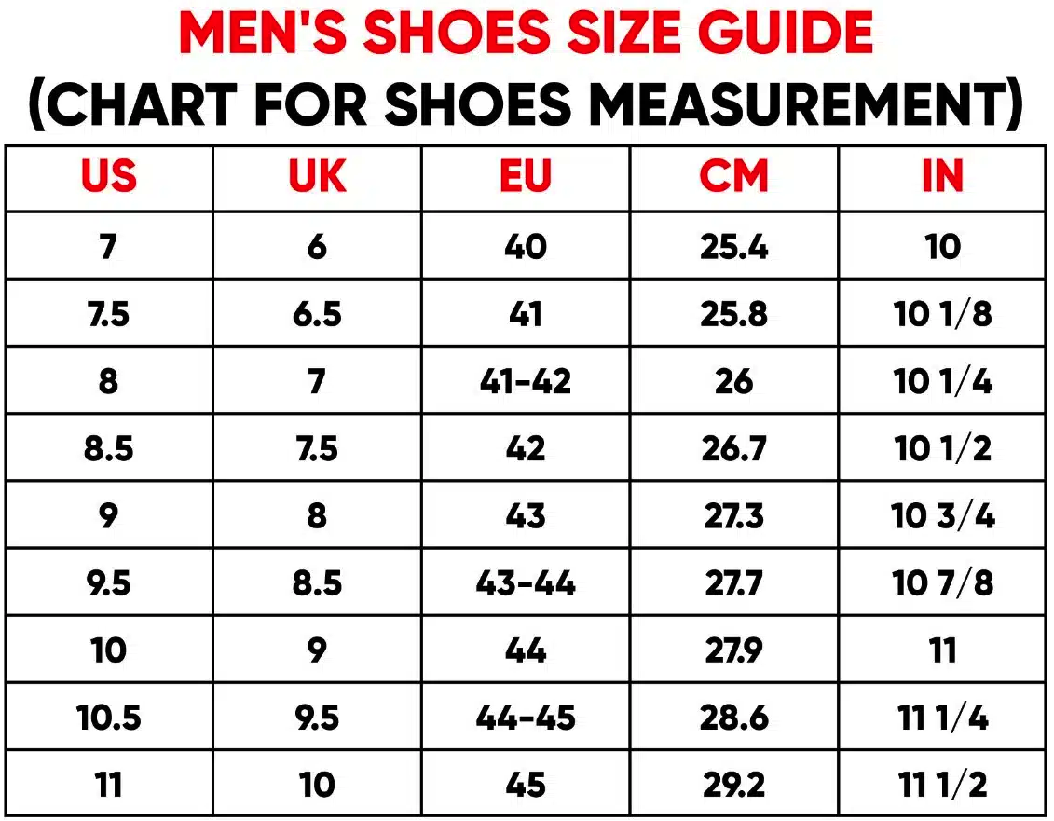
A guide for men’s shoe sizes is shown on the right, from this source.
- Based on your findings in the previous question(s), suggest the US shoe size that Scott was wearing when taking the measurements.

Briefly explain why you think so, justifying the degree of accuracy in your suggestion.

Although the US size 9 is very close to the results we obtained in previous calculations, it is slightly larger.

An argument could be made supporting the idea that Scott’s shoe size is not US-size 9, but rather US-size 8.5. His shoes might have thicker soles or might be a bit stretched out.

However, it is also possible that he wears US size 9, but his shoes shrunk a bit when they were last washed.

[D: 7-8, iv]

- Use the shoe size you suggested in question (11) that Scott was wearing when measuring the wall sections to find
  - the length of the northern and western walls in feet, inches, and centimeters, and
  - the floor area in square feet, square inches, and square meters.

Then, based on your findings, justify whether those values make sense.

Given that Scott wore US size 8.5 shoes, we have $S=10\frac{1}{2}÷12=0.875$ feet. Using this value for $S$, we find the following:
a)
- The length of the northern wall is $22\frac{1}{3}S+3=\left(22\frac{1}{3}\right)\left(0.875\right)+3=22.54166…$ feet. This is 270.5 inches or 6870.7 centimeters.
- The length of the western wall is $26S+3=26×0.875+3=25.75$ feet. This is 309 inches or 784.86 centimeters.
b)
- The floor area is
$$580\frac{2}{3}S^{2}+139S+9=\left(580\frac{2}{3}\right)\left({0.875}^{2}\right)+\left(139\right)\left(0.875\right)+9=575.1979 {ft}^{2}$$
This is 82,828.5 square inches or 53.4376 square meters.

Note: the values when using $S=10\frac{3}{4}$ (size 9 shoes) are the following:
- Northern wall: approx. 23 feet or 276 inches or 701.25 centimeters
- Western wall: approx. 26.3 feet or 315.5 inches or 801.37 centimeters
- Floor area: approx. 600 square feet or 86,330 square inches or 55.6968 square meters.

And now we know Scattered Scott shoe size! Well done!
[D: 7-8, iv]

